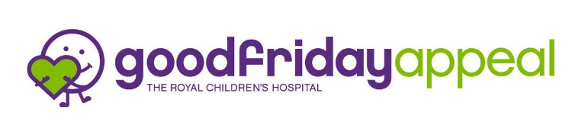
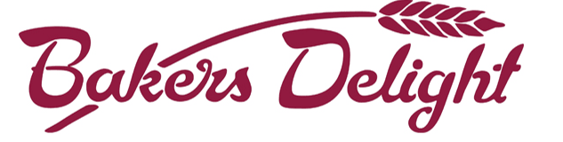
HOT CROSS BUN ORDER FORM

Bakers Delight Chirnside Park have offered us the opportunity to purchase their delicious Hot Cross Buns.
For every 6 pack of Hot Cross Buns, Bakers Delight Chirnside Park will give us $2.
Once again, this year we will give 50% of our Hot Cross Bun profits to the Royal Children’s Hospital Appeal.

Students Name: ____________________________________________Class: _________________Phone:________________________
Name | Traditional  $7.50 | Choc Chip  $7.50 | Apple Cinnamon  $7.50 | Mocha  $7.50 | Fruitless  $7.50 | Total Qty | Total  $7.50 per six pack
 |  |  |  |  |  |  | $
 |  |  |  |  |  |  | $
 |  |  |  |  |  |  | $

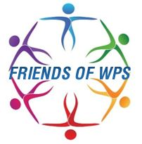
Ordering available on QKR – please ensure you use the “drop down box” feature to choose your flavours.
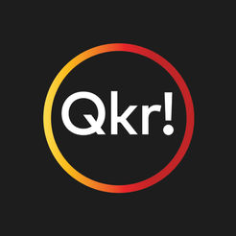
Alternatively, you can make payment at the office with cash / card.

